**Experiment No : 3**

**AIM**

Familiarization of LINUX Commands.

**CO2**

Perform system administration task.

**Procedure**

1. 7)pwd

print the working directory

$ pwd

Output

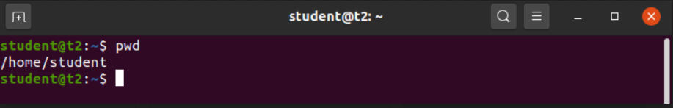

1. ls

to view the contents of a directory

$ ls

Output

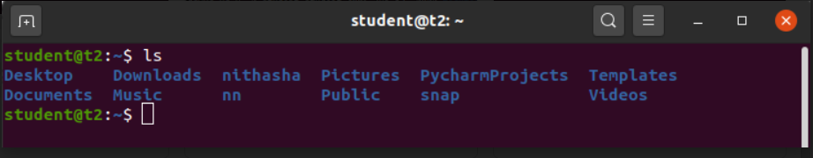

2.1) ls –R

List the contents of the subdirectories

$ls –R

Output

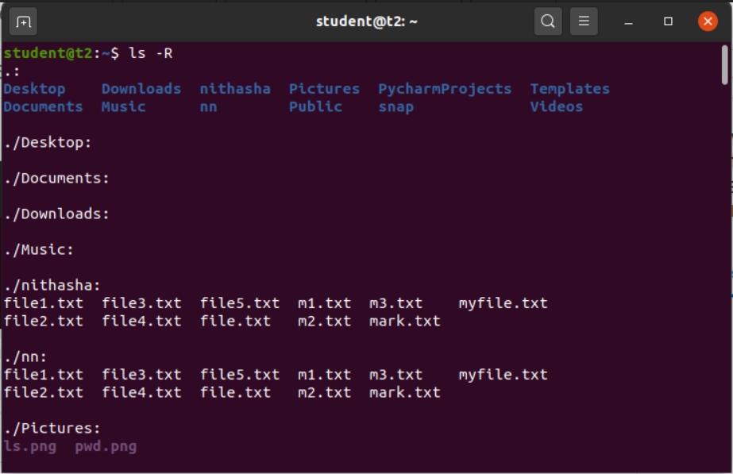

2.2) ls –l

Long listing of contents of directory

$ls –l

Output

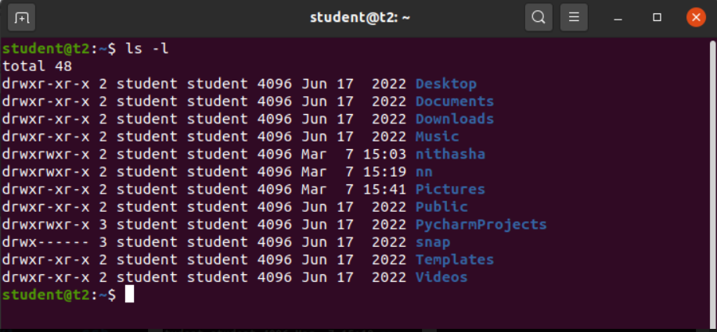

2.3) ls –a

Lists the hidden files in the directory

$ls -a

Output

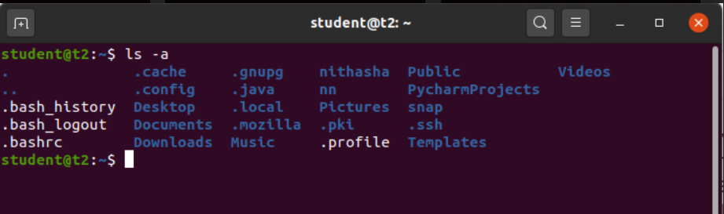

2.4) ls –al

Lists the directories & files with detailed information about owner, file size , permissions etc.

$ls –al

Output

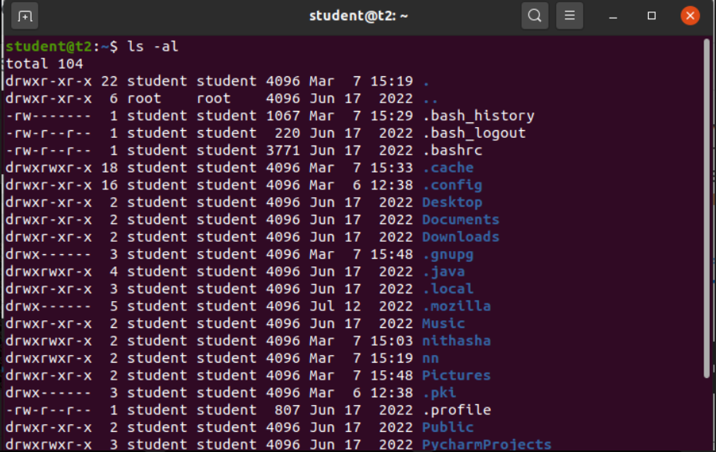

2.5) ls –t

Lists the contents in the order of last modified

$ls –t

Output

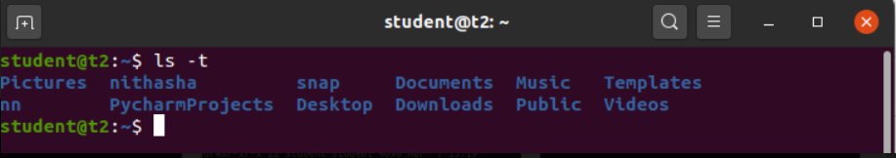

2.6) ls –r

To reverse the natural sorting order of the last modified date of directory

$ls –r

Output

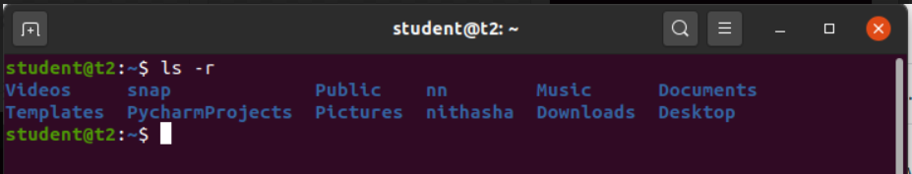

3) history

to review commands that have been executed for certain period of time.

$ history

Output

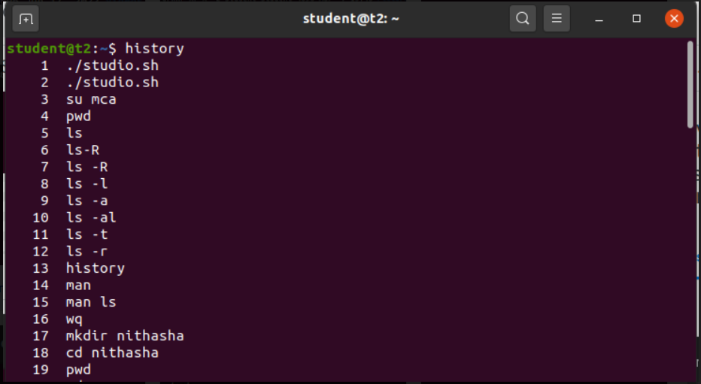

4) man [command]

To learn and understand about different commands

$man ls

Output

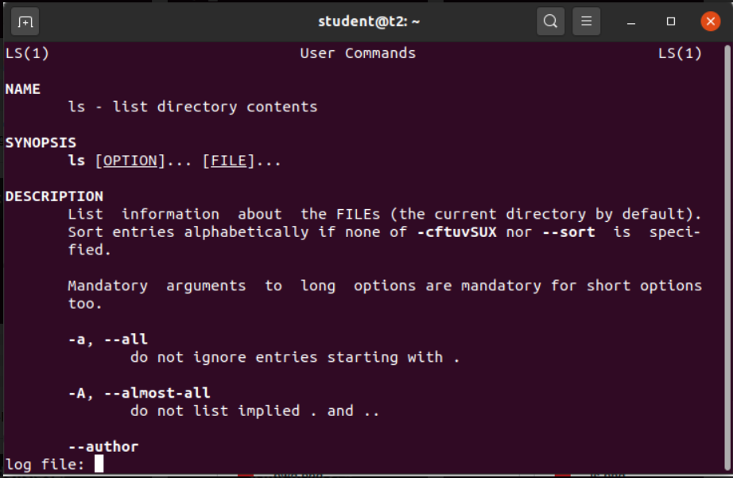

5) mkdir [new directory name]

Create a new directory

$mkdir sample

Output

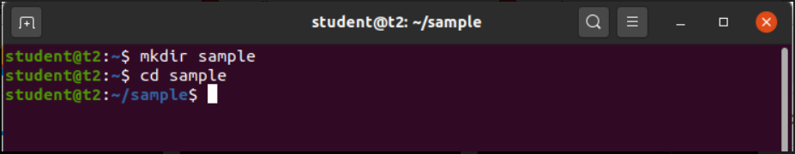

6) cd [directory name]

Change directory

$cd sample

Output



6.1) cd ..

To change directory to the previous one

$cd ..

Output



7) rmdir [directory name]

To remove a directory

$rmdir sample

Output



8) touch [filename]

To create an empty file

$touch file.txt

Output

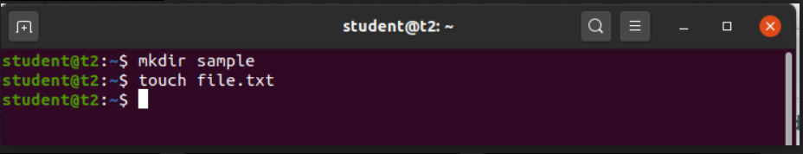

9) cat

To add content to the file

9.1) $cat > [filename]

To write content into a file.

$cat > file.txt

Output

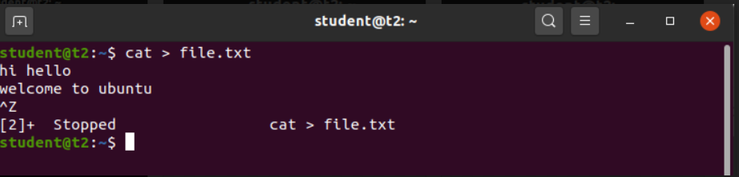

9.2) cat [filename]

To view the file content

$cat file.txt

Output

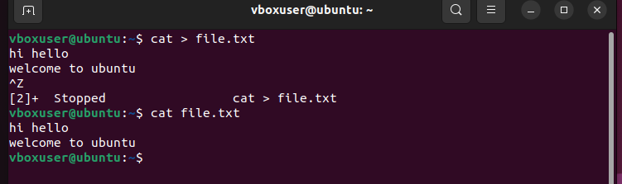

9.3) cat >> [filename]

Append content to the existing file

$cat >> file.txt

Output



9.4) cat –n [filename]

To display content with file numbers

$cat –n file.txt

Output

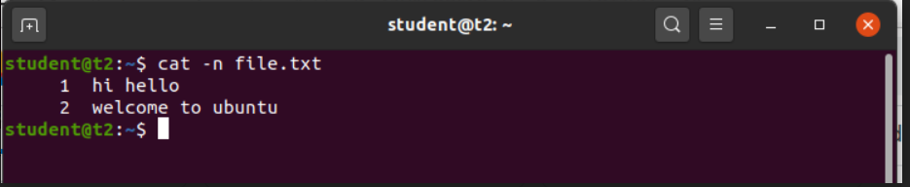

9.5) cat –b [filename]

Omits line numbers for blank space

$cat –b file.txt

Output

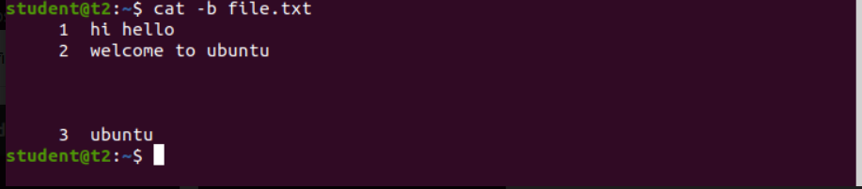

9.6) cat [filename1] > [filename2]

To copy content from filename1 to filename2

$cat file.txt > file1.txt

Output

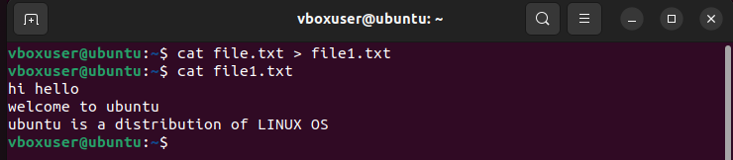

9.7) cat [filename1] [filename2] > [filename3]

To combine the contents of 1st 2 files to the 3rd file

$cat file.txt file1.txt > file2.txt

Output

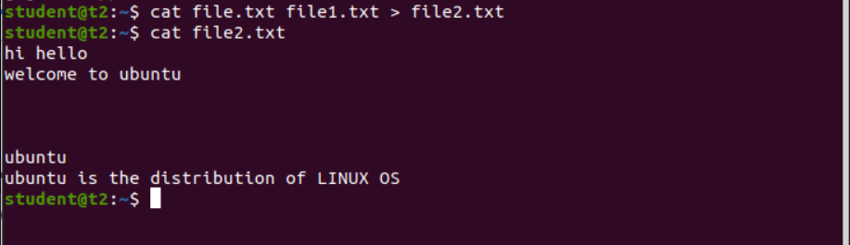

9.8) cat [filename1] | tr a-z A-Z > [filename2]

To change the contents of 1st file and save it into the 2nd file as uppercase

$cat file.txt | tr a-z A-Z > output.txt

Output

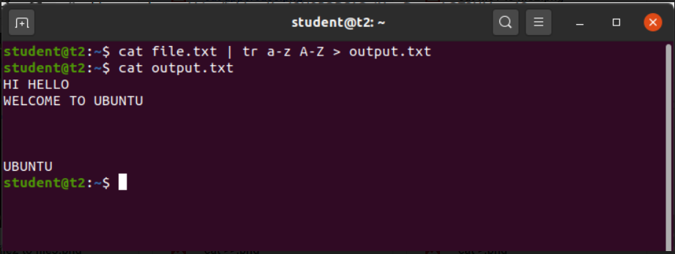

Result

The program has been executed and output has been verified.